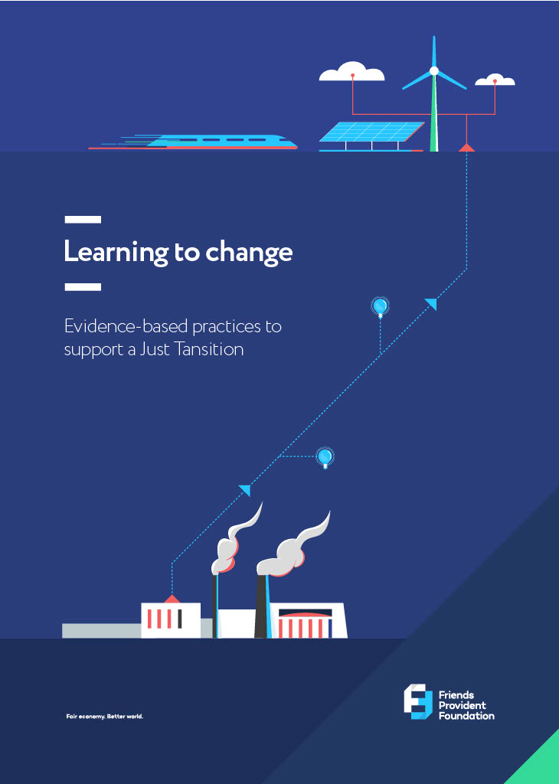

Introduction
A learning event organised by Friends Provident Foundation on 17 May 2023, via Teams, gathered insights from three Foundation-funded projects relevant to achieving a Just Transition to a zero-carbon economy. The projects were implemented by Forum for the Future, New Economics Foundation (NEF) and the Grantham Research Institute based at the London School of Economics (LSE). The aim of the event was to identify points of common learning, and to review both successful and unsuccessful experiences.
We hope our findings will serve as a resource for funders, policymakers, researchers and practitioners interested in understanding the complexities of implementing a Just Transition.
By promoting dialogue and knowledge-sharing, we hope to support the development of evidence-based policies and practices to ensure a Just Transition. The lessons learned and recommendations of these three projects can serve as a guide for future initiatives in this critical area and have long-term implications for creating systemic change.

What is a ‘Just Transition’?
A ‘Just Transition’ refers to a concept and framework developed to support the global move from an unsustainable and carbon-intensive economy to one that is more sustainable and low-carbon in order to tackle climate change (a ‘net-zero’ economy).
This transition is likely to have significant economic and social consequences, including job losses in industries that rely heavily on fossil fuels, economic disparities and social inequalities. There are social, economic and environmental challenges in this change for industries, communities and workers.
The Just Transition framework seeks to ensure that the burdens and benefits of the transition are distributed fairly among all stakeholders. It involves creating policies and strategies that prioritise the protection of workers’ rights, provide support for affected communities and promote inclusive and sustainable economic development.

Attendees

New Economics Foundation
Chaitanya Kumar (Head of Environment and Green Transition)

London School of Economics
Brendan Curran (Policy Fellow, Sustainable Finance)
Forum for the Future
Martin Hunt (Joint Managing Director, UK/Europe)
Friends Provident Foundation
Danielle Walker Palmour (Director)
Jo Wilce (Grants & Learning Manager)
Jake Furby (Communications Manager)

The Our Zero Selby project

Forum for the Future

About the project
The Our Zero Selby project aimed to explore and demonstrate the benefits to a local community of a Just Transition to a net-zero economy.
The project activities involved engaging with residents to help them identify tangible ways to improve their community while addressing carbon emissions and climate adaptation. The goal was to foster agency, collaboration and a positive narrative in a community that has endured previous waves of industrial transformation.
A collaboration between Forum for the Future and Involve, the project engaged with various stakeholders to understand and facilitate practical action within the community to generate co-benefits of climate action while reducing carbon emissions.
The process began with relationship-building and setting up governance structures, including an advisory group and a partnership group. Approximately 300–400 members of the local community were involved through engagements such as workshops and surveys. The project aimed to break down the abstract concept of the net-zero transition into tangible topics that were relevant to people’s daily lives.

Key findings
Focused and relevant community engagement: To make the net-zero transition relatable, efforts were made to meet the community where they were and to address their concerns. By making the transition tangible and focusing on topics and benefits that resonated with the community, the project successfully engaged participants. The materials and methodologies used were well received.

Trusted anchor institutions: Collaborating closely with Selby District Council and securing an additional project officer who was locally connected proved crucial. The presence of a trusted organisation with long-term commitment and local knowledge facilitated community engagement and the development of the project.
Anchor institutions are defined by the Centre for Local Economic Strategies as having an important presence in a place, usually through a combination of being large-scale employers, the largest purchasers of goods and services in the locality, controlling large areas of land, and/or having relatively ﬁxed assets. They are tied to a particular place by their mission, histories, physical assets and local relationships. Examples include local authorities, NHS trusts, universities, trade unions, large local businesses, the combined activities of the community and voluntary sector and housing associations.
Targeted business engagement: Engaging businesses in the net-zero transition presented some challenges. Business size was a key differentiator in how businesses responded to the project.
Some larger businesses had their own net-zero strategies, but found it difficult to translate them into meaningful engagement with the local community.
Anchor institutions play a critical role in driving the transition to a low-carbon and sustainable future, but their business models and most material sustainability concerns were not always aligned with local community needs.
Small businesses faced difficulties in understanding the advantages they would gain from the transition, or lacked the resources to invest in solutions, which emphasised the missed chances for cooperation between small enterprises and the Just Transition movement. Nevertheless, small business owners were sympathetic to the cause and understood that change needs to occur.
Micro/small business owners focused on actions they could personally undertake or implement within their households, rather than considering the implications of the zero-carbon agenda for their business operations. They may engage with the concept more actively if they were given concrete examples of business-related actions and measures that they could adopt and derive advantages from.
Support with finances and grant applications: Philanthropic giving to grassroots organisations and movement-building showed a positive trend. However, community organisations sometimes missed out on available grants due to a lack of internal capacity and resources for making applications. Grant-making organisations should consider the skill sets and capability of local organisations to ensure they have better access to this source of funding.
Initiating engagement and future steps: Initiating engagement with the local community in the post-Covid period took longer than desired, but was vital to the project. The existence of multiple parallel local government initiatives resulted in a state of ambiguity and confusion, primarily because of the constant shifts and overlapping responsibilities in roles and functions.
In 2023 Selby District Council merged into North Yorkshire Council, and the new council showed similar support and understanding for the Our Zero Selby project. However, securing financial commitments and resources for specific programmes and projects remains a challenge. Zero-carbon projects in Selby need access to programmatic funding and funds such as the Shared Prosperity Fund in order to grow and thrive.

Conclusions
The Our Zero Selby project demonstrated the importance of participatory methods, community engagement and collaboration in supporting a Just Transition to a net-zero economy.
By addressing the specific needs and concerns of the local community, the project fostered a sense of agency and showcased the long-term benefits of the transition. The participatory and representative methodology behind the project means the ideas it generated have a strong claim to local legitimacy, which should strengthen its case in fundraising applications.
The project demonstrates that securing funding, engaging businesses effectively, and upskilling local authorities will be crucial to the success and impact of similar projects in the future.

Skills gaps in Yorkshire and Humberside

NEF
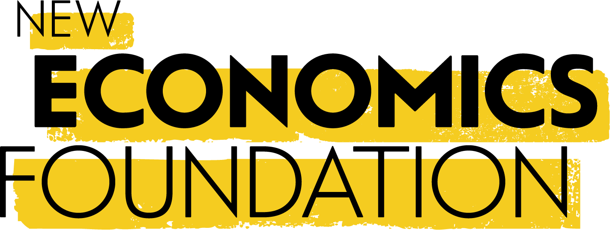
About the project
NEF carried out research and analysis in the Yorkshire and Humber region to understand the challenges and opportunities related to skills and the Just Transition to a low-carbon economy. It explored the context of the region, the importance of trust in managing the transition, and the significance of sectors such as utilities, mining, manufacturing and construction. It found that there is a need for upskilling and retraining programmes to support workers through the transition, and identified skills gaps in various industries.

Key findings
The skills gap: The average skill level of workers in the Yorkshire and Humber region is lower than the national average, which presents a significant challenge.
Regional skill disparities: There were disparities within the region, with some areas having a greater proportion of individuals with higher qualifications. Overall, the region lags behind the rest of the country in upskilling and reskilling (see figure below).

A slow increase in number of green jobs: As the low-carbon transition gains momentum, the number of ‘green jobs’ is expected to increase. While in certain areas, such as Selby and Lincolnshire, there were already a number of green jobs, in other areas they appeared to be lacking. This suggests that the overall growth in green job opportunities is yet to be realised.
Training: The report estimated the number of weeks’ training required for a typical worker in the region to reach the national average skill level for a green job. With the right policies and incentives, the skills gap can be addressed.

Recommendations
A social partnership approach: It is important to involve unions and workers in the transition process. A social partnership approach should be adopted, similar to successful models used in the European Union.
A national strategy for a skilled labour market: The absence of a comprehensive national strategy is a barrier to achieving long-term goals. Existing policies, such as the apprenticeship levy, should be reformed to encourage firms to invest in upskilling and reskilling their workforce.
Skills credits and public procurement: Policy ideas such as the introduction of skills credits (inspired by the United States) and leveraging public procurement could be used to stimulate upskilling and reskilling initiatives.

Lessons learned
A tangible focus on skills: By addressing skills gaps, policymakers and stakeholders can provide practical solutions that would support the Yorkshire and Humber region and its workforce in achieving a Just Transition.
Unions’ diverse perspectives: Different unions hold diverse views on the transition to a low-carbon economy, posing a challenge for unified action. Collaboration and open dialogue are necessary to align perspectives and ensure workers are effectively represented.
Engaging elected mayors: Regional elected mayors play a critical role in ensuring a Just Transition. Mayors need to develop a bold vision encompassing multiple sectors and areas, to effectively address the challenges.
Post-pandemic challenges: The post-pandemic focus on job creation and labour market recovery has diverted attention from the longer-term goals of a Just Transition. Stakeholders must shift the focus of public policy on a Just Transition toward addressing the cost-of-living crisis and long-term sustainability.

Conclusions
The Yorkshire and Humber region presents significant challenges and opportunities for a Just Transition to a low-carbon economy. Key issues to be addressed include skills gaps, engaging the unions and implementing targeted policies. Elections and industrial strategy are potential avenues for advancing the transition agenda

The role of finance in enabling a Just Transition

The Grantham Research Institute on Climate Change and the Environment (LSE)

About the project
This project considered the social challenges and complexities faced by different regions, actors and sectors, and the role of financial institutions and businesses, in making the transition to a net-zero economy. It highlights the need for strong policy direction and the consideration of social risks and opportunities. Its findings underline the importance of putting people at the centre of net-zero planning, and of meaningful social dialogue and participation in the transition process.

Key findings
Understanding the Just Transition: The concept of a Just Transition does not have a single universal definition and will have some variation in scope and focus. While organisations such as the International Labour Organization have established principles, what is considered crucial to delivering a just and inclusive transition will vary across different regions and countries. It is important to understand the nuances and differences in each transition and how different groups are affected by it.
Factors of a Just Transition: Three key factors for a entity to consider when responding to the Just Transition are:
- Anticipate, assess and address the social risks of the transition.
- Identify and enable the social opportunities of the transition.
- Ensure meaningful dialogue and participation in net-zero planning.
Businesses and financial institutions must assess and address the social risks associated with transitioning to a net-zero economy. Additionally, there is potential for new product innovation and business opportunities that align with sustainability goals. Dialogue on this issue must acknowledged the challenges and complexities of achieving a Just Transition, particularly for major corporations and financial institutions.
International trends and progress: The term ‘Just Transition’ has gained prominence in international climate negotiations and initiatives. Various organisations, such as Climate Action 100 Plus and the World Benchmarking Alliance, have attempted to measure and promote Just Transition progress. The terminology around ‘Just Transition’ may not align with the current UK government’s preferences, but it is important to address the social aspects of the transition in policy discussions.
The role of financial institutions: Financial institutions play an important role in achieving a Just Transition. They are already committed to principles such as human rights and labour standards, but they must go beyond these commitments to consider the social implications of their investments. Engaging with the social aspects of the transition is necessary for broad-based support, political buy-in and the development of the required skills and human capital.
Research and applied guidance: Guidance should be tailored to international frameworks. It is important to facilitate the adoption of Just Transition strategies by investors and businesses. There have already been successful collaborations with investors, such as Royal London Asset Management, in applying Just Transition frameworks and measuring progress.
Challenges and policy implications: There are challenges in ensuring the credibility of Just Transition efforts and avoiding ‘justice washing’ or using the concept as a delaying tactic. There is a need for consistent measurement frameworks and ongoing efforts to drive Just Transition strategies across various sectors. A Just Transition commission has already been established in Scotland and there are plans for the same in Northern Ireland. Local-level initiatives such as net-zero investment portfolios are also needed, to foster a sense of ownership and engagement among communities.

Conclusions
It is important to integrate the social aspects of the Just Transition into financial institutions’ strategies and investments. A strong policy direction, meaningful social dialogue and active engagement with stakeholders will support a successful and equitable transition to a net-zero economy. Ongoing research, collaborations and initiatives are needed to ensure that progress continues, and to encourage further efforts to measure and promote Just Transition outcomes.

Key conclusions
These three projects reflect the challenges, opportunities and strategies involved in implementing a Just Transition to a net-zero economy.
- The Our Zero Selby project emphasises the significance of community engagement, trusted anchor institutions, business engagement and financial considerations in creating a Just Transition at the local level.
- At a regional level, the ‘skills gap’ project highlights the importance of supporting workers to improve their skills or learn new ones, involving unions in the process, and implementing a comprehensive national strategy for upskilling and reskilling.
- The project exploring the role of finance in this process underscores the need for meaningful social dialogue, consideration of social risks and opportunities, and the active involvement of financial institutions.
Collectively, the projects emphasised the importance of participatory methods, collaboration and addressing local community needs. They highlight the significance of engaging all stakeholders, including communities, businesses, unions and financial institutions, in shaping and implementing effective strategies. They also underline the need for strong policy direction and supportive frameworks to support the Just Transition agenda.

Key lessons
Tailoring approaches to specific contexts: Understanding the unique circumstances and needs of the target audience is crucial for success.
Active collaboration and partnership building: Engaging various stakeholders, including community members, businesses, unions, financial institutions and local authorities, is essential. Building partnerships and leveraging trusted anchor organisations can foster effective engagement and cooperation.
Community empowerment and agency: The Our Zero Selby project highlighted the significance of empowering communities and fostering a sense of agency. By making the net-zero transition relatable and focusing on topics that resonated with community members, the project successfully engaged participants. Involving communities in decision-making processes and enabling them to shape their own sustainable future can build a sense of agency and commitment.
Targeted skills development and reskilling: Upskilling or reskilling programmes can be targeted to equip workers with the skills needed in ‘green jobs’. This not only supports individuals but also contributes to the achievement of a net-zero economy.
Policy coherence and direction: Strong policy direction and supportive frameworks are essential for driving the Just Transition agenda. Comprehensive national strategies, reforming existing policies and consistent measurement frameworks are all required. Clear and coordinated policies can provide guidance, foster innovation and incentivise businesses and institutions to align their practices with sustainability goals.
Meaningful social dialogue and active engagement with stakeholders: Open and inclusive dialogue helps to align perspectives, build consensus and ensure that the transition to a net-zero economy is equitable and socially beneficial.
Continual learning and adaptation: The challenges faced by those working to achieve a Just Transition can provide learning points of immense value to others in the field. This iterative approach allows for improvements and better outcomes in future efforts.
In summary, achieving a Just Transition requires a multi-faceted approach that considers the needs and perspectives of diverse stakeholders. There must be collaboration, investment in skills development, supportive policies and the active involvement of financial institutions in order to ensure the shift to a sustainable future is both equitable and successful.

Green jobs can be varied; the research considered direct jobs (e.g. solar panel installer), indirect jobs (e.g. operations manager at a wind farm) and induced jobs (e.g. scientific researcher).

