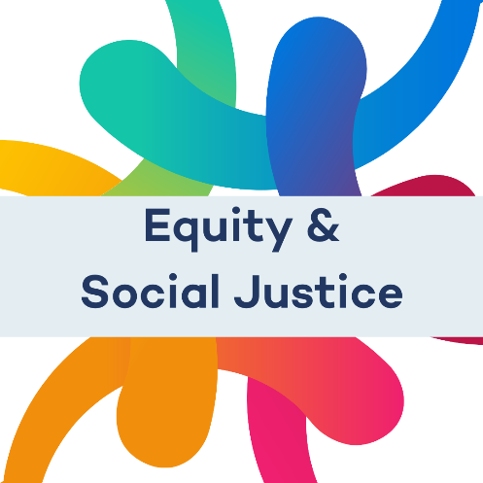

Equity and Social Justice Update
May 2022

Background
This is our first update on our equity and social justice plan. You can access this report as a word file, a html website page and as a pdf document.
Over the past year we have been focusing on developing and integrating equity and social justice within all our work. We have been thinking hard about how equity and social justice interacts with the economy and how marginalised individuals and groups are often excluded from the conversation and decision-making. This report is an update of where we have got to so far.
For us the current economic system is inequal, and our mission is to reform the economy to create a fairer and more sustainable world for all. We believe this work is urgent, we have under a decade to address the effects of climate change and we need to challenge the inequality that marginalised people face. All of these issues, need new bold ideas, to address the ill affects individuals and groups experience within the current economic system. We need to tackle deep issues and unpick the deep underlying oppressive structures which have for so long excluded marginalised people’s experiences and voices.
Friends Provident Foundation is therefore committing to including equity and social justice within our work, ensuring that it intersects across our programmes.
We are considerate and conscious that changing our practices, work culture and increasing our understanding of equity and social justice issues takes time. We are taking this from a place of learning, and we don’t have all the answers.
This paper highlights some our thinking and work we have undertaken to date. We are sharing this because one of our beliefs is to be transparent and accountable to the people and communities we serve.
We would also like to thank the trustees and staff members who have taken this project on.

Our Purpose
Friends Provident Foundation is an independent charity that uses all of its assets and pursuits a fair and sustainable economic system. We connect, fund, invest and share learning to shape an economy that works for all.
To create a fair and sustainable economy we must be proactive at addressing equity and social justice issues. We have created a working group of staff and Trustees to develop this piece of work. In the future, we aim to integrate this work across the Foundation’s activities.
We understand that we have power to influence, advocate and create the conditions for change to occur. However, this power can also cause social injustices and reinforce power differences between different groups. It is therefore crucial for us to approach our work through an equity and social justice lens.

Who is leading this work
We are taking a whole organisation approach to this work; however, the integration of equity and social justice is being led by Aphra (Trustee), Ann (Trustee), Priya (Trustee), Abby (Grants Manager), Colin (Investment and Engagement), and Jake (Communications Manager). We all have different backgrounds and experiences and are informed by intersectional approaches.
We will also be supported by Guppi Bola an independent advisor who will be advising us on our training programme.

Introduction
We as a philanthropic sector can be guilty of virtue signaling and we can struggle to create deeper and meaningful change. We need to:
- focus on system change rather than symptoms
- align our strategy with findings from our grantees, meaning we need a wider pool of diverse voices,
- ensure that we are living the values we expect of others
- use all of our resources for change.
Therefore it is important we ensure that communities furthest from power are represented and listened too.
Currently the foundation positionality is one off transitional, where in which we will sit in the equity and social justice space for some time before moving to a transformational approach.

Key terms
Inequality – unequal access to opportunities
Currently the economic system does not work for everyone – it is both the cause and the result of systemic inequality.
Examples of inequality include: women and ethnicity pay gaps, working class individuals less likely to be high income earners despite their abilities and achievements, and trans people more likely to be unemployed owing to their gender identity.
Equality - treating everyone the same
Many people conceive of equality as treating everyone the same, however, there are individuals and groups of people who do not start from the same starting point. Therefore, it is impossible to achieve social justice through equality alone. However, we should recognise that it has been powerful tool in creating an increased respect to marginalised people.
Examples of equality include: horizontal economic theories, Equality Act (2010),
Equity - is when you apply a range of tools to address inequality
Whilst equality treats everyone in the same way, equity seeks to understand and give people what they need as a means of ensuring fairness.
It is important for us to look at other models to achieve equality through an equity and social justice lens, we do not have all the answers and we believe that there are multiple ways in which to achieve this. At the time of this writing the Foundation feels that it needs to sit within the equity space, as it is a new way of thinking for the foundation.
Social Justice – everyone being able to access tools and opportunities and reach their full potential
We seek to remove the barriers that prevent equity and equality by creating the conditions for change to occur. We do not have a model, as we believe this would become reductionist in our approach and not reflect the communities we seek to serve.
We would eventually like to fix the economic system by removing barriers and ensuring people having both tools and opportunities to influence and be equally part of the economy. We can do this by creating an approach which seeks to remove the barriers that prevent equality.
It should be noted that we see environmental and sustainability issues as a social justice issue.
Below is an illustration which nicely demonstrates these definitions:
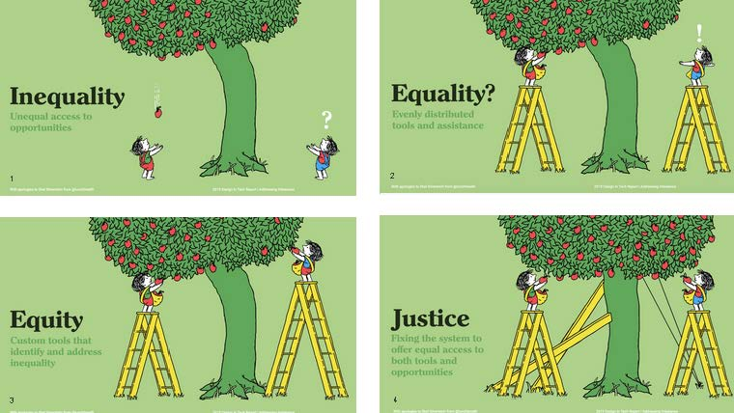
Equity and social justice for us is a continual process.
“This means dispensing with the idea of social justice as a place at which we arrive or for which we strive. Instead, the work of social justice is the striving; it is not a place but rather a process. The process of social justice means striving for each other’s wellbeing. As such, a more socially just world is more people striving for and with each other” (Huffman, 2014: p.3).
We shall not be taking a particular lens, but instead welcome the complexity of not knowing what the answer is.

Current roles within the organisation

Trustees | Staff | PAG and EAG | Contractors | Partners
Legally responsible for the organisation.  Mainly focuses on governance but do help with operations. | Mainly operational but co-creates strategies with the trustees which inform our work.  We have the following staff positions:  - Director  - Investment Engagement Manager  - Grants Manager  - Grants and Learning Manager  - Finance and Operation Manager  - Officer Manager  - Communications Manager | Support us with delivering our grant programme | Aid and support us to develop the orgaisation’s aims and objectives.  Do we wish to add that we encourage/expect organisations to have a commitment to equity and social justice | Aid and support us to develop the orgaisation’s aims and objectives.  Do we wish to add that we encourage/expect organisations to have a commitment to equity and social justice

Analysis of the problem
As an organisation we are aware of how the economy impacts and (re)produces inequality within the current system.
We were assessed by the Foundation Practice Rating which is a tool that assess charitable foundations on diversity, transparency and accountability found that we:
- Have a lack of alternative documentation on the website, therefore causing a barrier for disabled people;
- Have a lack of options for disabled people to contact the foundation;
- Are not producing documentation in Welsh;
- Do not provide a breakdown of staff and trustee demographics;
- Do not publish our diversity plan.
In addition, we commissioned Guppi Bola (Independent Advisor) to look at implementing diversity and intersectionality within the organisation, from this report the foundation has committed to:
- A review of our theory of change

What have we done so far?

- Formed a working group.
- Drafting an equity and social justice plan.
- Reviewing our grants programme, where equity and social justice will be part of the programme.
- Developing a training programme.
- Campaigning for the ethnicity pay gap.
- Made a commitment to sharing a breakdown of staff and trustee demographics.
- Starting to produce documents in alternative format and developed metrics to monitor our progress on this.
- Developed an accessibility communications checklist.
- Invested in a tool which can translate our website into different languages and provide accessibility tools.
- Are a leading funder of the Foundation Practice Rating.
- Developing an equal opportunities policy.

What are we are focusing on next?

- Completing the equity and social justice plan.
- Launching our new grants programme (August).
- Equity and Social Justice training to have started.
- Publish breakdown of staff and trustees demographics.
- Ensuring documents are available in alternative formats.
- Finish writing the equal opportunities policy.

Meyer Spectrum Tool (adapted)
We are using this tool as grounding and reflective exercise to see where we are and where we need to get too.
Equity and Social Justice Component | Not Yet Started | Ready to Start | Launched | Well on the Way | Exemplary or Leading
Equity and Social Justice Vision | Does not see it as relevant | We Recongise the importance of Equity and Social and we are complementing next steps  [We are developing an action plan] | Equity and Social Justice programme launched | Have developed Equity and Social justice and is integrated within our work | Have integrated Equity and Social Justice within our organisational mission and statements, and these are being actively used.
Commitment | Does not have an interest in advancing DEI work | Is interested in advancing equity and social justice work and is considering how to do so  [We are developing an action plan] | Interested in advancing equity and social justice work and has put some strategies or actions in motion | Is actively engaged in advancing equity and social justice. | Fully committed at all levels for equity and social justice.
Leadership | Trustees and staff have not taken on equity and social justice issues. | A few members of trustees and staff are leading equity and social justice work | An equity and social justice is leading the organisaiton’s equity and social justice work | All levels of management are actively taking leadership on equity and social justice [some trustees and staff involved] | Building the field and best practices and is accountable.[e.g. FPR]
Policies | Does not have any policies | Does not have but interested in developing policies | May have some equity and social justice language within policies [EDI policy] | Has a policy/plan but not sure how to implement it | Has a plan with clear goals, strategies and indicators
Infrastructure | Has not had an internal discussion about the organisation’s equity and social justice work | Has had some internal equity and social justice discussions, but doesn’t have an infrastructure to guide the work | Smalls groups are guided by equity and social justice but not in the wider organisation | Has internal committees that have power to be able to implement changes [Equity and Social Justice Working Group] | Work on equity and social justice is integrated into every aspects of the organisation
Training | Has not done any equity and social justice training | Is contemplating doing training [Training menu] | Some staff or trustees have attended equity and social justice training | All trustees and staff are involved in equity and social justice training and capacity building | Has ongoing training. Staff and trustees are accountable
Diversity | Does not see the need to have a diverse board and staff team | Has had conversations about the importance of having a diverse board and staff team [In trustee meetings] | Beginning to attempt to diversify the board | Actively works to increase diversity of the board and staff team | Has policies and strategies to increase diversity on board and staff team
Data | Does not collect demographic data | Currently does not collect demographic data but see it as a future goal [grant making, make up of staff/trustees] | Collects some data but not in a systemic way | Collects data across programmatic and other areas but might not know what to do with the data | Collects data across programmatic and other areas but knows what the data represents.
Community/Marginalised groups | Does not see the point of engaging with marginalised groups | Value the idea of of building partnerships but does not know how | Beginning to build partnerships but has not yet implemented accountability [e.g. Decolonsing Economics] | Actively works to build relationships and partnerships. | Has mutually beneficial, accountable and equitable relationships that has addressed power issues
Decisions | Equity and social justice issues do not factor into decision-making | Interested in factoring equity and social justice, may say it is an add on | Decisions are occasionally made because of equity and social justice [Investment Engagement/Grants] | Decisions about governance is informed by using an equity and social justice lens | Decisions about govenance are systematically guided by equity and social justice
Accountability | Equity and social metrics are not used in staff or trustees | Values Equity and social metrics [Ongoing discussions on what is the best way to achieve this]. | Preparing to include Equity and social metrics | Equity and social metrics used across some of the organisation | Equity and social metrics used across the organisation
Inclusion | Does not see the need to create an inclusive organisation | Values the idea of being an inclusive organisation | There is space for equity and social justice and inclusion discussions but individuals are required to conform to the dominate culture | The voices of staff and trustees who experience marginalisation are heard and the organisation is in transition from a dominant culture to an inclusive – multicultural culture | All staff and trustees feel valued and listened too. The organisation has transited to an inclusive multicultural organisation and have policies in place to keep this.

